[15/5/2022]

Assessment One

Develop ICT Solution

Wells International College

[Shimpei Oshikiri 70359]

|  |  |  |  |
| --- | --- | --- | --- |
| Name of Student | Shimpei Oshikiri | ID | 70359 |

Contents

Case scenario 2

Heaven Systems internal IT Service Agreement 3

Task 1: Scope issue 4

**Protect yourself from phishing attempts** 5

Task 2: Selected solutions with Presentation 5

Presentation 6

**Search Index** 8

**REFERENCE:** 8

**Assessment 1 – Presentation**

***Instructions:***

You need to analyse a case scenarios and complete tasks mentioned after scenario.

You need to demonstrate your develop ICT solution ability to identify the solution, determine client support and manage the team in development an awareness of cyber security in workplace.

***Duration:***

Trainer will set the duration of the assessment.

***Evidence required:***

|  |  |  |
| --- | --- | --- |
| *Tasks* | *Evidence* | *Submission* |
| Identifying issue and | A complete issue report and selected solution, including a presentation. | Presentation in front of the class and the trainer. Also, in printing |

# Case scenario

Established in 1999 with offices located throughout the western Sydney, Heaven Systems is a world-class, full-service provider of residential, commercial, and logistics-based transportation solutions for businesses and individuals. Many of the world’s largest, most respected corporations rely on the company’s unwavering commitment to innovation, quality, and customer service to move their employees, offices, and industrial facilities—domestically and internationally—anywhere in the world. Heaven Systems was experiencing an increase of phishing emails that were reaching employee inboxes and introducing the risk of a data breach. As phishing attacks increased, productivity slowed down while end users waited for IT to investigate the suspicious emails. “Phishing emails were getting more specific and sophisticated, and we worried that an employee might open one and cause serious damage,” said David Potter, IT Director at Heaven Systems. While there are multiple layers of security to filter email as it enters Heaven Systems’ network, it’s still possible for some targeted phishing emails to slip through and get into employee in-boxes. For this reason, IT must rely on end users to determine whether an email is safe to open. But it’s not always easy to tell. “For instance,” said Potter, “one area of the company was getting phishing emails that looked legitimate. They appeared to come from a customer, but the attachment was malicious.” Refer to employee background statistic show below:

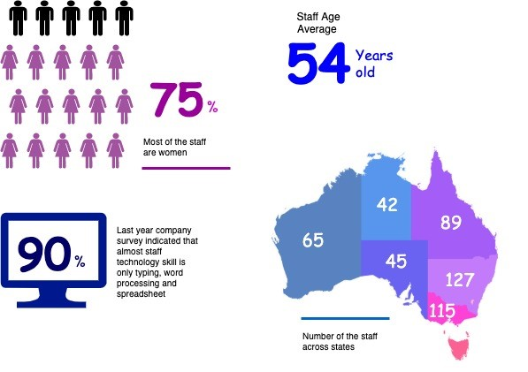

To help employees identify phishing emails, IT holds annual training to show them what red flags to look for. Then, IT sends mock phishing attacks to test them. If a user clicks on a couple simulated phishing emails, they’re required to take the security training again. Human nature being what it is, some users were ignoring legitimate email because they didn’t want to make a mistake that would require them to take the training again. Others decided to play it safe and send every questionable email they received to IT to see if it was OK. While IT recognized the obvious threats, even they had to question some of the attachments. “You can imagine the amount of time we spent investigating emails,” said Potter. “It took about an hour per email to copy the attachment to a USB drive and then spin up a machine to test the file off network,” he explained. “That’s valuable time that IT could spend doing other things.”

You are work as an IT project manager assigned by Potter to handle this problem in the company. The company decide to use the system to detect a Spear-Phishing. To accelerate suspicious email analysis and response, Heaven Systems implemented MailMon, an automated phishing incident reporting and response service that empowers end users to report suspicious emails directly from the inbox. MailMon runs on Microsoft Exchange 2013 or newer and Office365; it is deployed to end users as an Outlook plug-in, including Outlook App for Android and iOS devices.

You and your friend are 10 years’ experience staff in the company. After you evaluate the MailMon, it generates a report in the complex form, many of the staff including a current IT department are not familiar with the system. Potter approved on new project team recruitment, and HR organised 3 **new graduated** IT staffs joining your team. Potter would like your team to gain more awareness on this cyber security incidence.

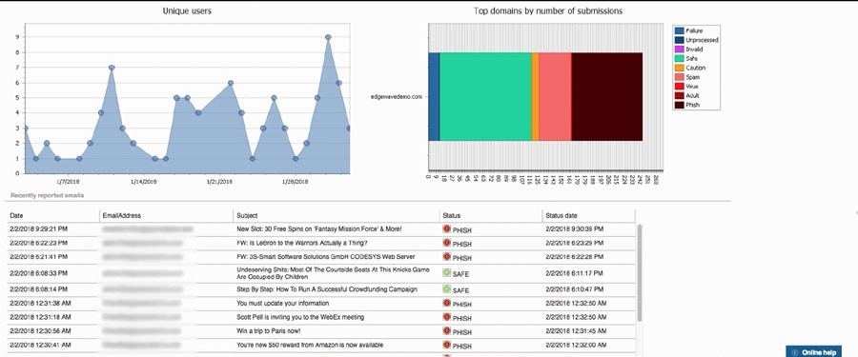

Figure: MailMon Monitoring Sample

# Heaven Systems internal IT Service Agreement

|  |  |  |
| --- | --- | --- |
| **Severity Level** | **Description** | **Target Response** |
| 1 (Outage) | Entire Company Server down | Immediately |
| 2 (Critical) | Entire Department Server down | Within 15 Minutes |
| 3 (Urgent) | Staff computer down | Within 1 hours |
| 4 (Important) | Staff computer not work properly or potential for interrupt their routine work | Within 3 hours |
| 5 (General) | Upgrade software  Training request | Within 48 hours |

# Task 1: Scope issue

Now, in the mid of November, you are required to prepare the report for the management team on company security awareness. The report should indicate:

1. The company current issue:

Heaven Systems was experiencing an increase of phishing emails that were reaching employee inboxes and introducing the risk of a data breach. As phishing attacks increased, productivity slowed down while end users waited for IT to investigate the suspicious emails.

**More ICT security issue attached in the end of this assessments**:

Ransomware is a type of internet virus which makes computers serious problem.

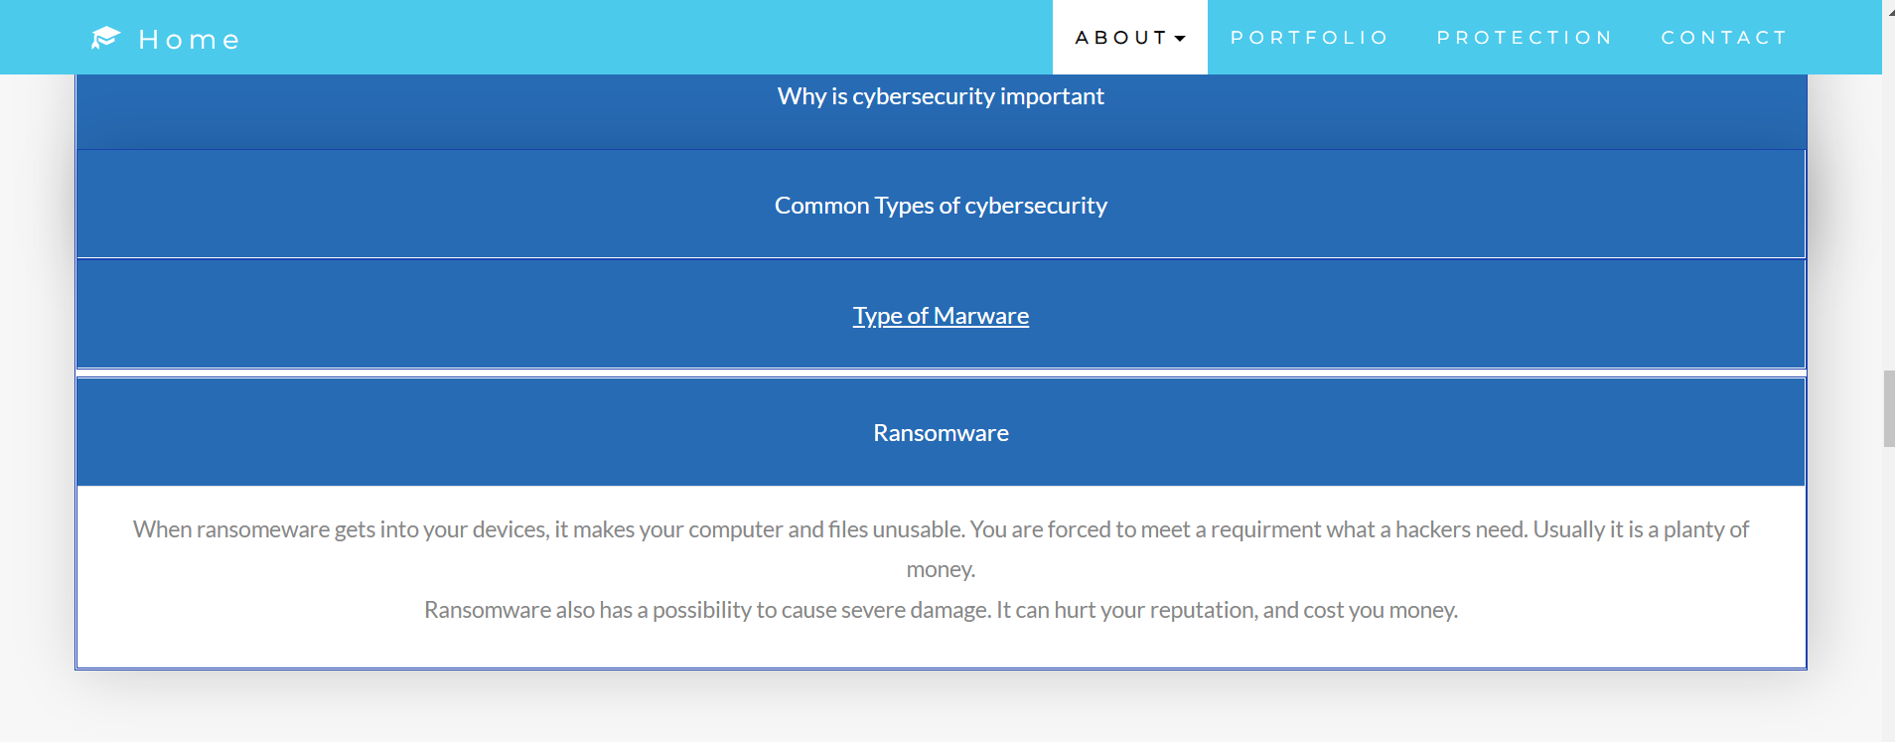

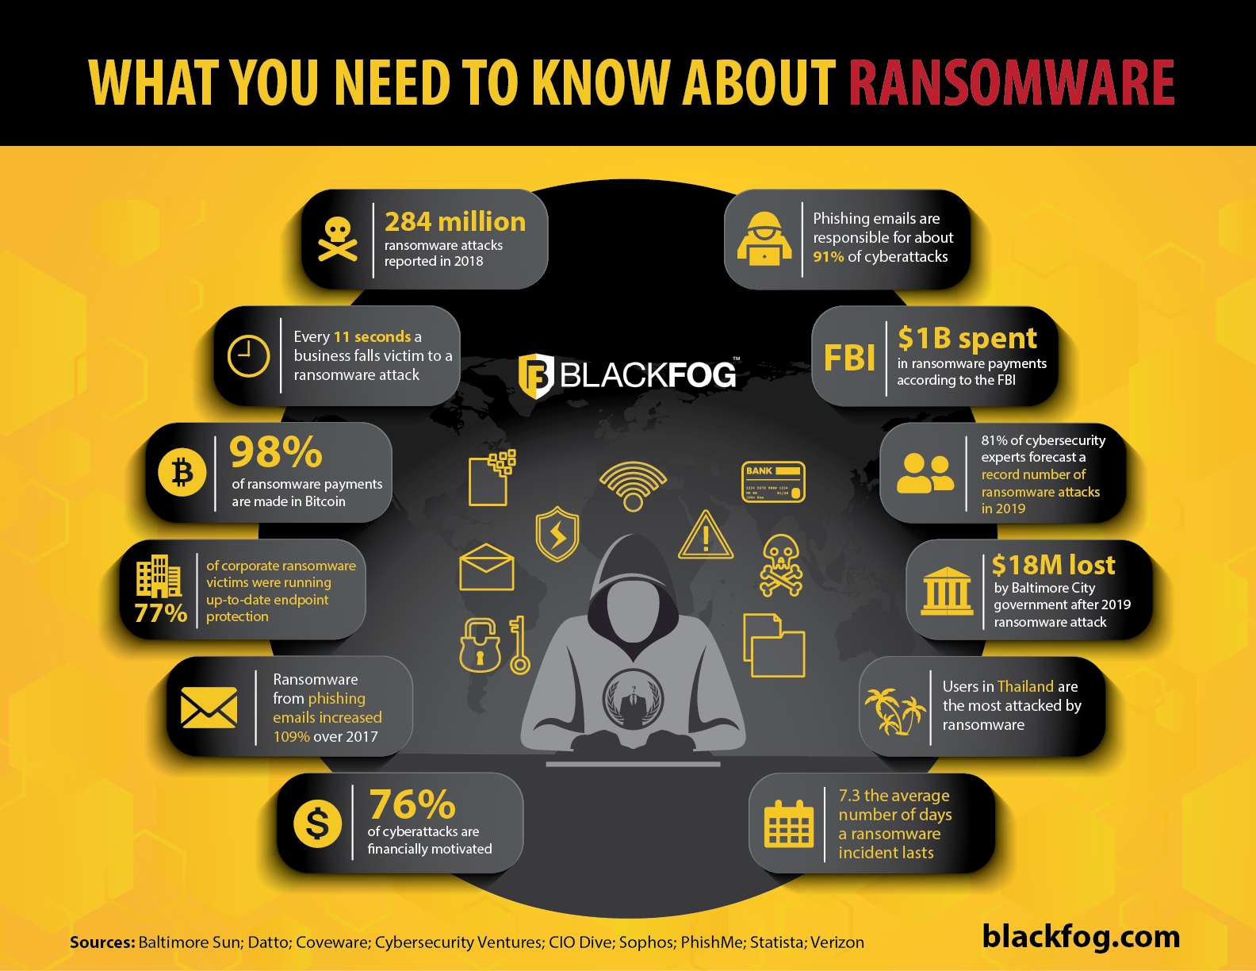

1. Brief for possible solution to identified issue. Each solution must be assessed on
   * commercial potential
   * suitability for the target audience or purpose
   * feasibility of implementing solution

refer:[Ransomware - Cisco](https://www.cisco.com/c/en/us/solutions/security/ransomware-defense/what-is-ransomware.html)

**Ransomware encrypts a victim’s data, after which the attacker damages a ransom.**

**Once you paid the ransom, the attacker sends a decryption key to recover the damaged data.**

**An attackers basically aim company to require a plenty of money that is from a few hundred dollars to millions of dollars.**

Ransomware is typically distributed through a few main avenues. These include email phishing, malvertising (malicious malvertising), social engineering, and exploit kits.

**How do I have to avoid ransomware?**

**User**

* Install security software
* Update your device to latest version frequently
* Do not open emails or attached files which are from unknown person

**Manager(Company,Government)**

* Make backup data and store in isolated memory
* Educate users and employees about whom and what to trust
* Limit the resources that an attacker can access
* Know your enemy and take advantage of threat intelligence from organisations to understand the latest security information

**How to deal with if you get ransomware**

* correct information what kind of ransomware did you get
* Use system restore such as Windows10(some ransomware makes this service ineffectual)
* Use decryption that a security company provide, like “No more Ransom”.

# Task 2: Selected solutions with Presentation

[ACSC - What is Phishing on Vimeo](https://vimeo.com/497805556)

1. Conduct a brainstorm on identified issue
2. Compare an idea solution for identified issue
3. Selected the solution and communicate to stakeholder (Your trainer)

a. **Prepare some (15) presentation slides** to present the following items to your trainer (All group members have to present equally)

* + Identified issue
  + Brainstorming evidence
  + Selected solution

1. Record feedback from your trainer and finalised the solution

# Presentation

**I added document on my ICT web site**

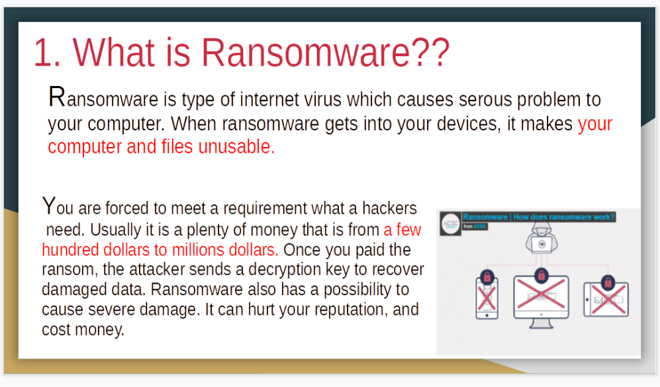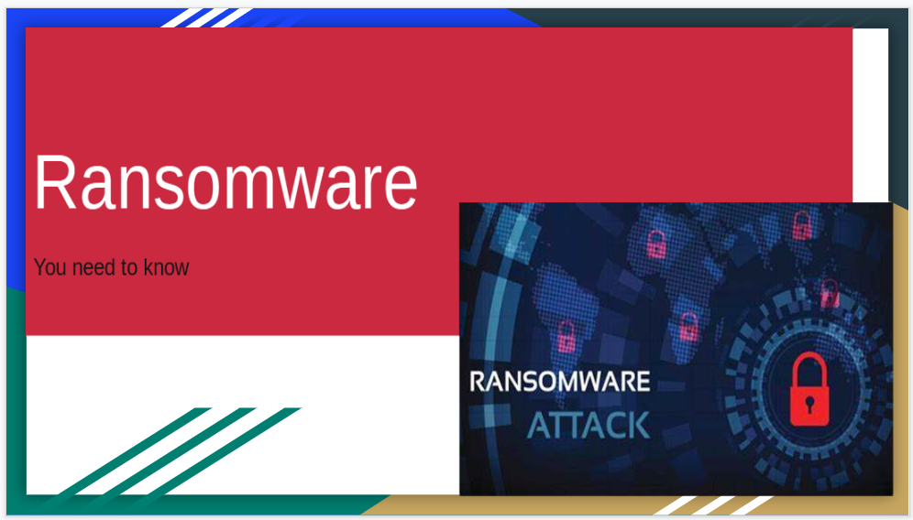

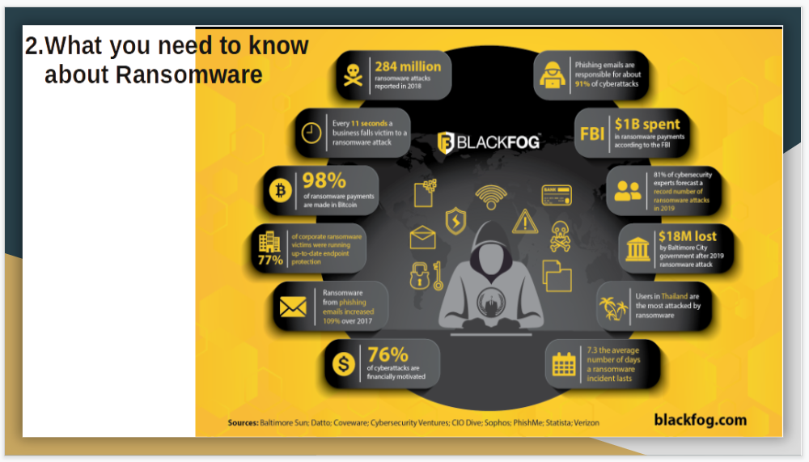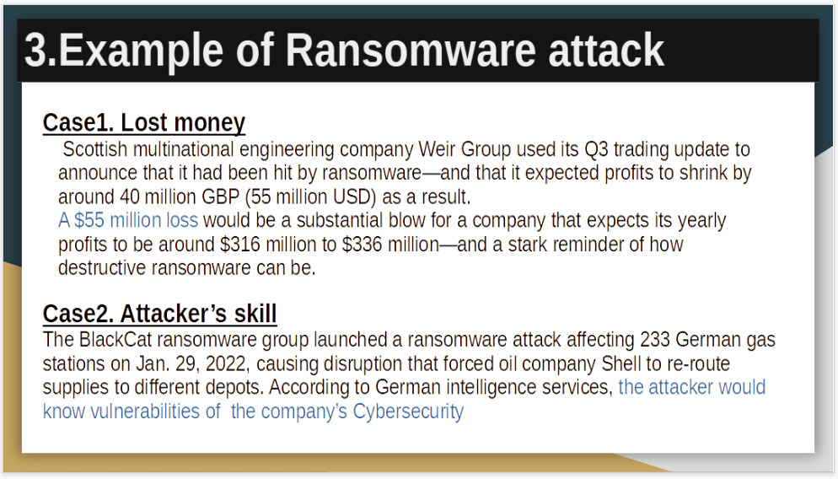

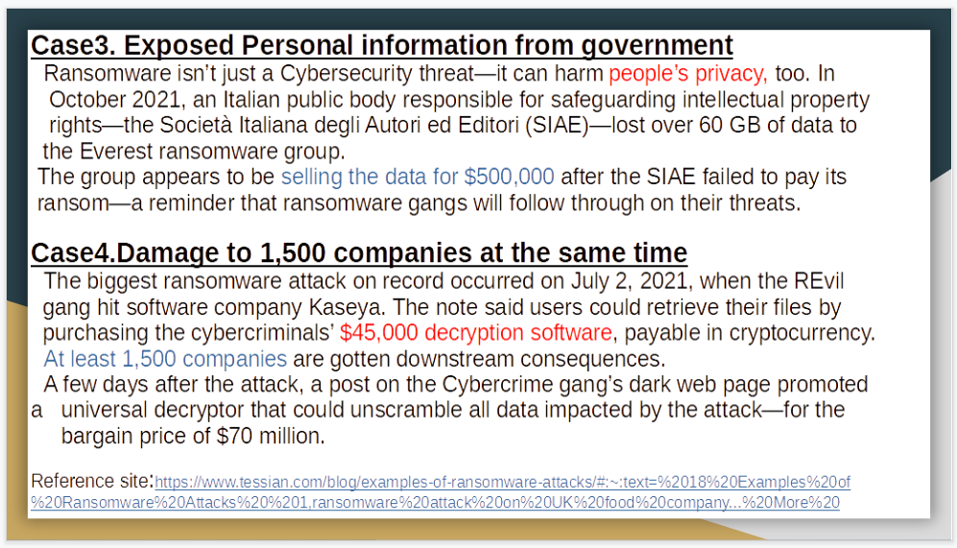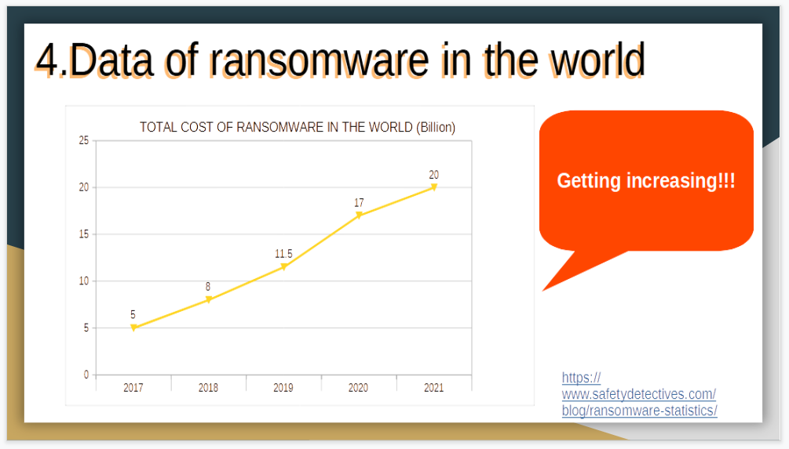

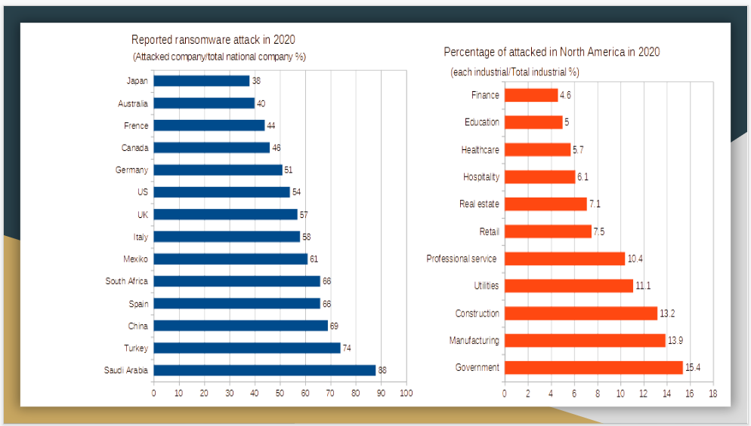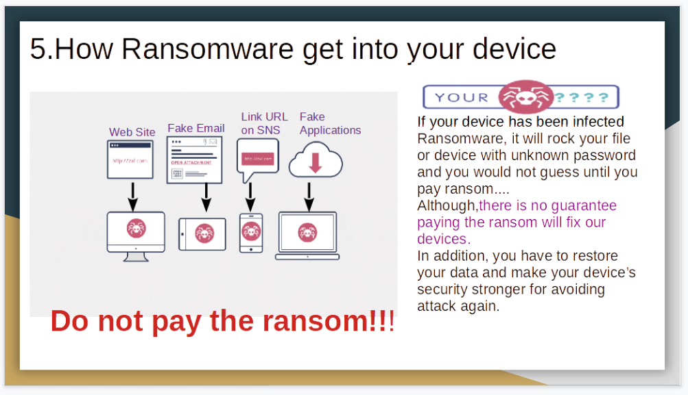

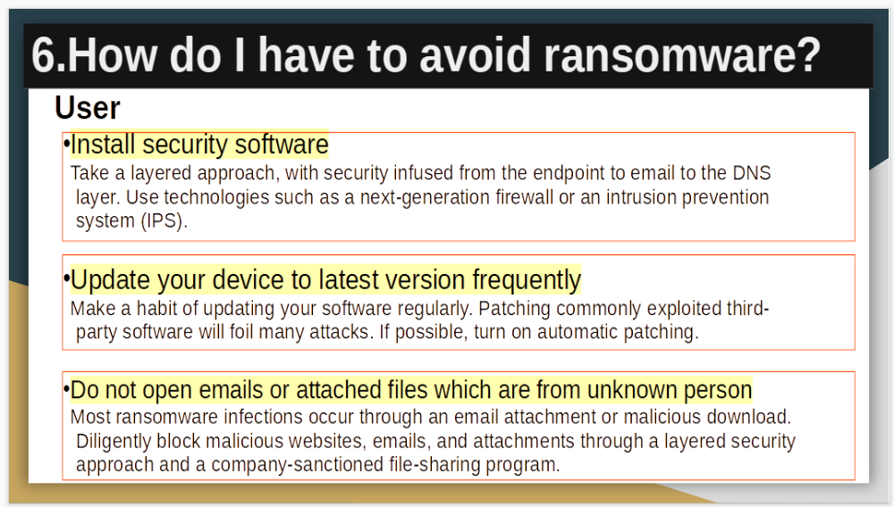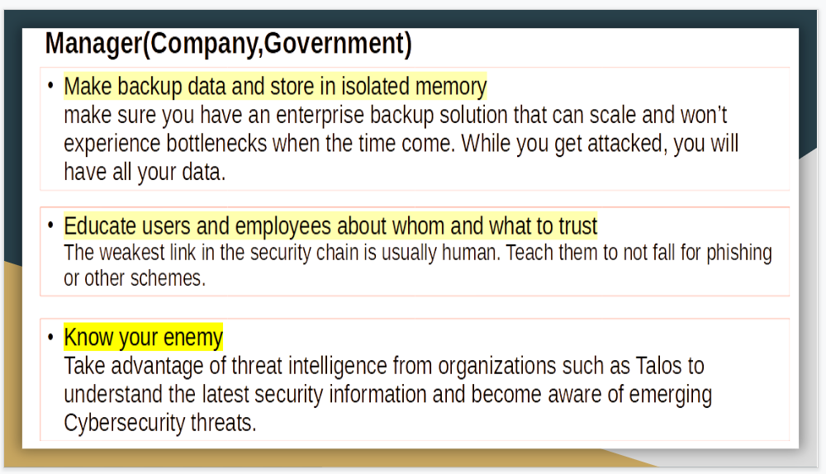

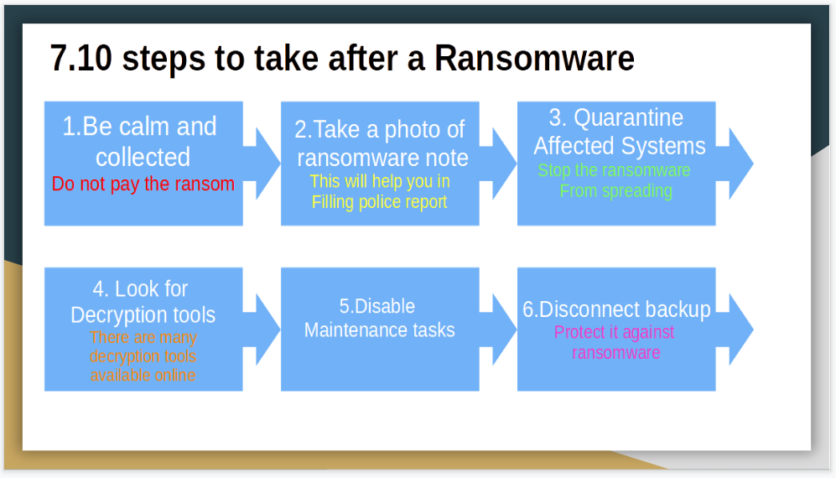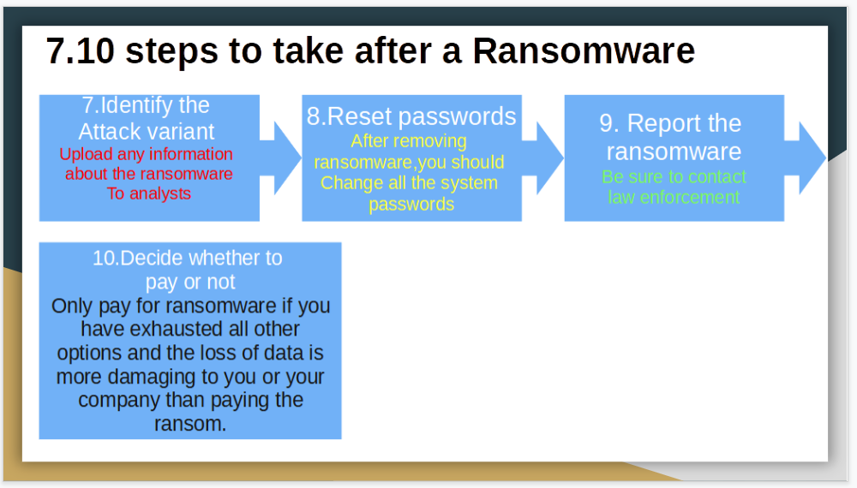

# **Search Index**

B

Brainstorming 6

C

cybercriminals 5

D

detect a Spear 3

H

Heaven Systems 4

I

idea solution 6

P

phishing attacks 2

phishing emails 2

# **REFERENCE:**

See my case study about ICT security case

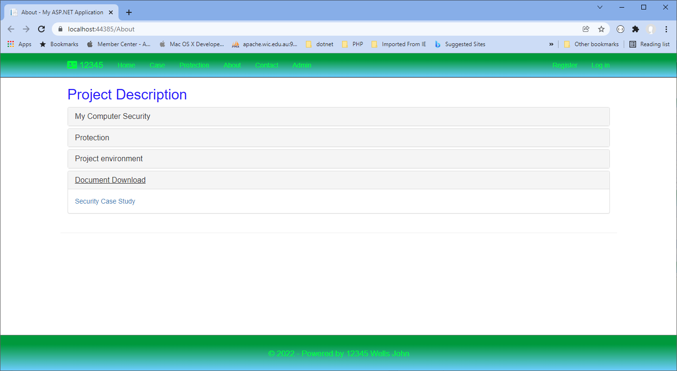

My database injection study

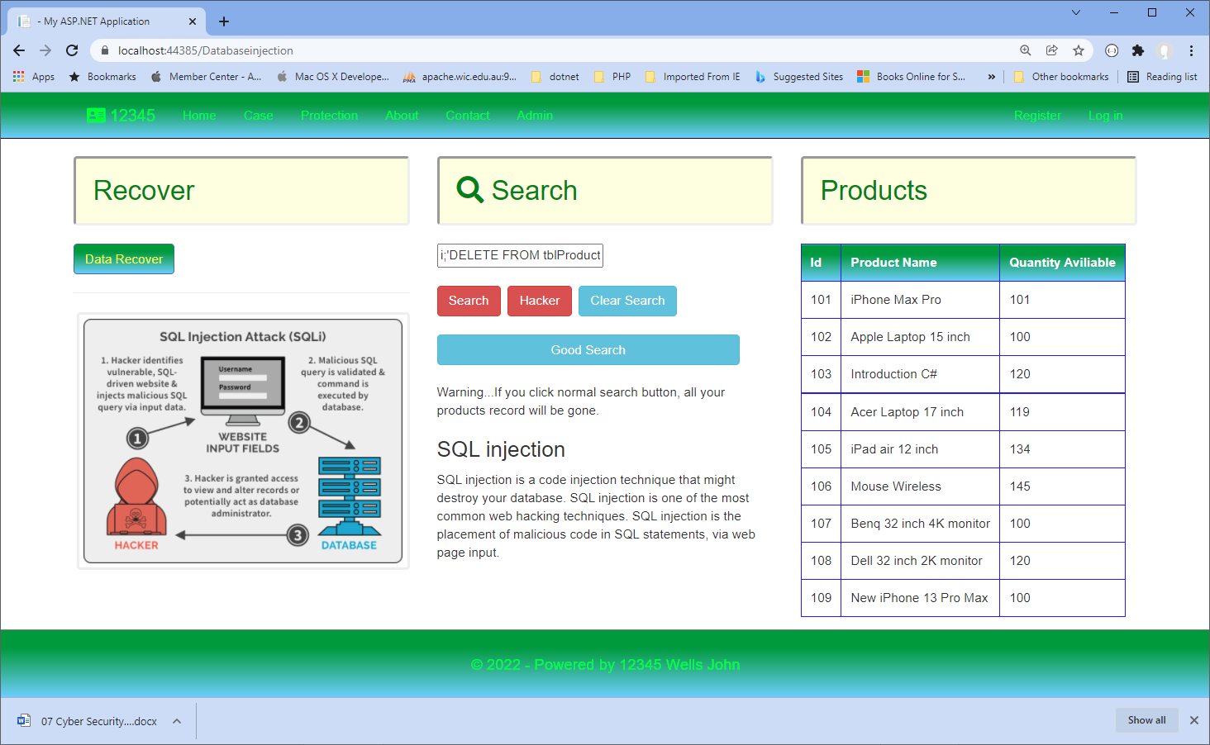

Communication safe example:

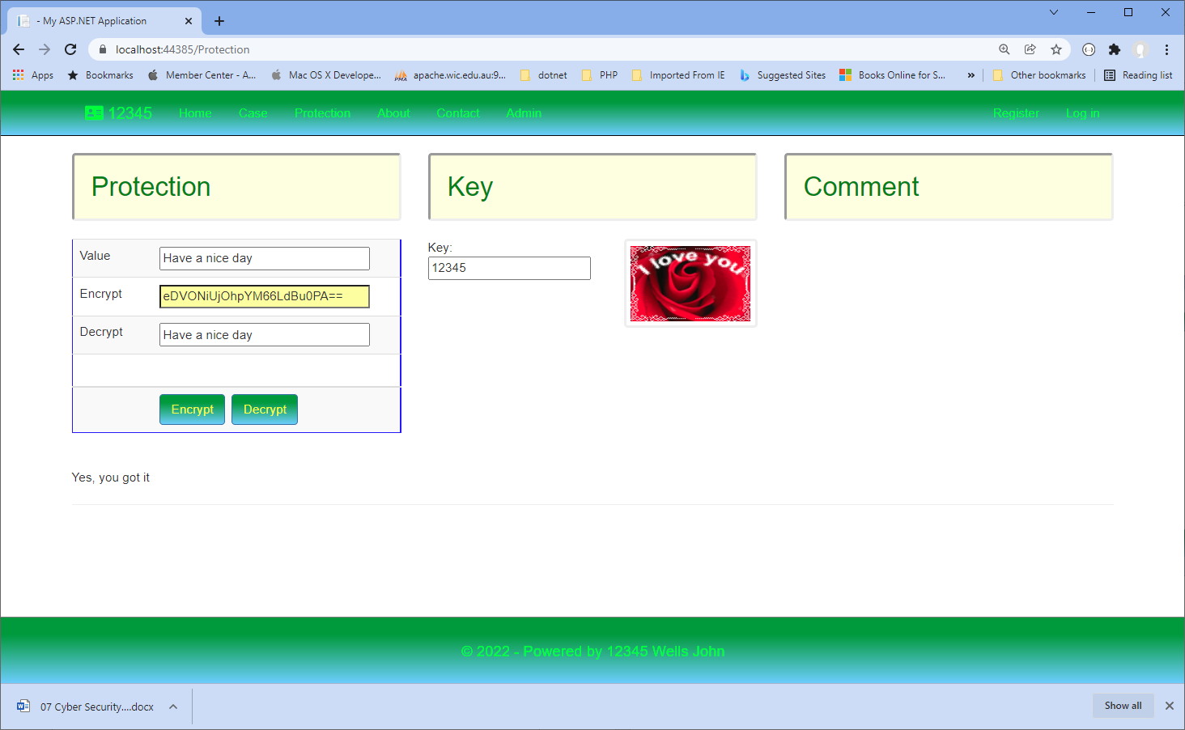

My computer work environment:

